On behalf of the U.S. Embassy in Ljubljana, Slovenia, I am pleased to welcome you to TechCamp Slovenia “Advocating for a Cybersecure World.”

As you know, TechCamp is a U.S. State Department initiative that aims to connect organizations, like yours, with the technology community to help increase your digital literacy, growth, and outreach potential.

TechCamp Slovenia is a regional event for participants from Slovenia, Serbia, Croatia, Bosnia and Herzegovina, Kosovo, Montenegro, North Macedonia, and Albania. This event will help equip the participants with the skills needed to inform the public and key policymakers of the need for, and resources available to enhance cyber-security, and to galvanize action toward protecting vulnerable systems, media ecosystems, infrastructure, and other vital networks.
Specifically, the event is focused on enabling participants to inform and advocate key constituencies such as the general public, government agencies and policymakers, and critical private sector or other public stakeholders on the need for (1) concrete cybersecurity improvements (either structurally or politically), (2) cyber security cooperation within the region, (3) cybersecurity hygiene generally, and (4) attention to key cybersecurity vulnerabilities (such as ports, infrastructure, power grids, 5G networks).

We will work with you to discuss ways in which new technologies can be used to help further your mission and make a positive impact in your local community and wider region.

If you are arriving in Ljubljana via air, your transfer to the hotel has been arranged by the embassy. Please look for a sign with your name upon arrival.
o Airport pick-up: All scheduled airport arrivals will be greeted by a driver at the Airport Arrival Lobby with a sign – your NAME or TECHCAMP. In case you miss the scheduled pickup/driver you can call
MAYA, BLED TRANSFERS, 0038640203405 Whatsup Viber to schedule a taxi pickup. You should provide your name and password “TECHCAMP” when scheduling a pickup.

A single room has been reserved for you at Hotel Astoria, Prešernova cesta 44, Bled (www.hotelastoria-bled.com) which is just across the main street to the TechCamp venue, IEDC Bled, Prešernova cesta 33, Bled (www.iedc.si). The embassy is covering your accommodation at the hotel (overnight with breakfast) any additional hotel charges you make will be charged to you individually upon check-out.

We will kick off TechCamp Slovenia on Wednesday, May 18th, at IEDC Bled at 5.00 p.m. with registration and orientation gathering, “speedgeeking” and informal reception. Please register at the registration booth (at the entrance) where you will will receive your credentials and an updated agenda.

The working language of the training is English. Dress code for the training is business casual.

TechCamp Slovenia will continue Thursday, May 19th, with coffee beginning at 8:30 a.m.
Please find enclosed list of trainers, list of participants, and a draft agenda.

You will receive an invite to our slack platform this week where you can follow the instructions to join and introduce yourself.

We are also sharing an on-line platform for this event - TechCamp Slovenia – TechCamp (america.gov)

We look forward to meeting you soon in Bled, and we hope you will find the event and your stay here useful and enjoyable.

Sincerely,



Michael J. Marble
Public Diplomacy Officer
U.S. Embassy Ljubljana
THE HOTEL
HOTEL ASTORIA BLED
Prešernova 44, SI - 4260 Bled
T: +386 4 579 44 00
E: astoria@vgs-bled.si

TECHCAMP VENUE
IEDC Bled
Prešernova 33, SI - 4260 Bled
www.iedc.si

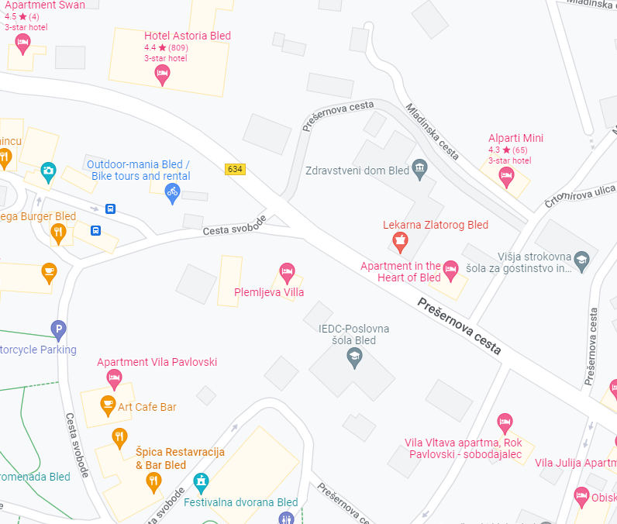

LIST OF TRAINERS/SPEAKERS/GUESTS (as of May 9, 2022):
Last Name | First Name | Organization
Haley | John | Senior Manager, Capital One Financial
Pearson | Brooke | Google
Ensign | Melanie | Discernible Inc
Listes | Mark | CEO, Pendulum
Viksne | Elina | Senior expert, National Cyber Security Policy Coordination Section, Ministry of Defense of Latvia

Konstantin Andrew Estonia

LIST OF PARTICIPANTS (as of May 9, 2022):
Last Name | First Name | Organization | Country
Braha | Jetmir | Director of Authorizations | Albania
Cekani | Ermela | Specialist at National Authority on Electronic Certification and Cyber Security/Albania | Albania
Harizaj | Miranda | Department of Statistics and Applied Informatics | Albania
Martiri | Edlira | University of Tirana, | Albania
Mezini | Dritan | DM Consulting Services | Albania
Kulovac | Adnan | Assistant minister-Head of K4 department, MOD BIH | BIH
Osmanagic | Kenan | Ministry of Transport and Communications | BIH
Gros | Stjepan | University of Zagreb's Electrical Engineering and Computing Faculty | Croatia
Abazi | Tanzer | Findbug SH P. K. | Kosovo
Berisha | Rexhe | Ministry of Internal Affairs, Republic of Kosovo | Kosovo
Erblind | Morina | Sense Cyber Research Center | Kosovo
Gerguri | Dren | University of Pristina, Department of Journalism | Kosovo
Hulaj | Astrit | Telecommunication, Government of Kosovo | Kosovo
Karahoda | Arti | Sense Cyber Research Center | Kosovo
Selmanaj | Drinor | CEO of Cyber Academy | Kosovo
Venhari | Gyen | Radio Television of Kosovo, Republic of Kosovo | Kosovo
Djukic | Zeljko | Multimedia Montenegro | Montenegro
Dujovic | Ljubomir | One Crna Gora DOO | Montenegro
Jelena | Danilovic | Digital Forensic Center | Montenegro
Krivokapić | Biljana | The Association of Teachers of Math and Informatics | Montenegro
Besimi | Adrian | South East European University | North Macedonia
Jashari | Bardhyl | Metamorphosis | North Macedonia
Mileva | Aleksandra | Faculty of Computer Science | North Macedonia
Andrejic | Mihajlo | Office for Information Technologies and eGovernment | Serbia
Bogdanovic | Ninoslava | SHARE Foundation’s Computer Emergency Response Team | Serbia
Đuric | Dejan | Technical Directorate Government of Serbia | Serbia
Jovetic | Jovana | Office for Information Technologies and eGovernment | Serbia
Likusic | Bojana | Office for Information Technologies and eGovernment | Serbia
Ratkovic | Dalibor | Pulsec Group | Serbia
Bernik | Igor | Faculty for Security Studies, University of MB | Slovenia
Cimpric | Boris | Ministry of Defense | Slovenia
Delakorda | Simon | Institute for Electronic Participation | Slovenia
Dvorsak | Adriana | University Medical Centre Ljubljana | Slovenia
Gorensek | Tilen | IPM Digital | Slovenia
Kavcic | Marijan | Slovenian Government Information Security office | Slovenia
Kordic | Mak | CEO @ CNJ digital | Slovenia
Markelj | Blaz | Faculty of Criminal Justice and Security | Slovenia
Sobocan | Tjasa | CEED Slovenia | Slovenia
Spagnolo | Gregor | OWASP | Slovenia
Zaletel | Anze | Iskraemeco | Slovenia
Dosti | Denanda | freelance journalist | Turkey

